SHRI PANCHAM KHEMRAJ MAHAVIDYALAYA, SAWANTWADI
DEPARTMENT OF COMPUTER SCIENCE
PRACTICAL NO. : 3 | ROLL NO. : | 02
SUBJECT: Data Science. | CLASS : | TYCS
AIM : Feature Scaling :  - Apply feature-scaling techniques like standardization and normalization to numerical features. | DATE : | / / 2025
SOFTWARE USED : IDLE (Python 3.13). | TEACHER SIGNATURE

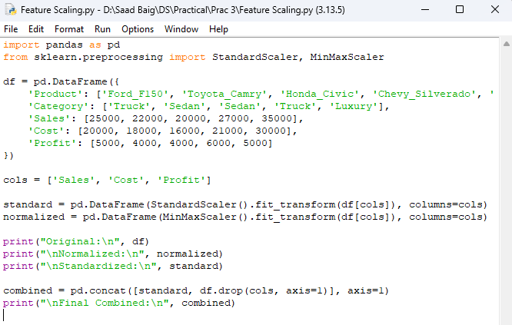
CODE

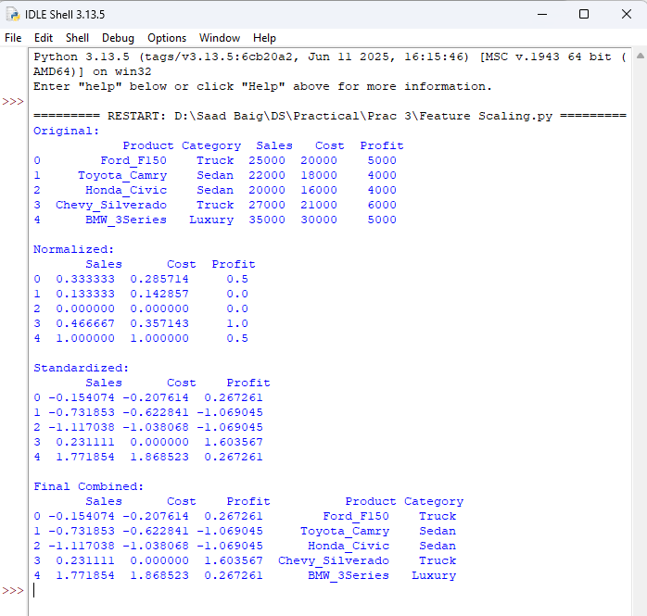
OUTPUT

